Andrew Mann

11/13/2022

Foundations of Python

Assignment 05

Introduction

The task within module 5 was to learn about the use of lists versus dictionaries in python. Dictionaries seem like the more advantageous when needing to pair data to a specific value. They seem a lot more like something that would be used by systems that would need to modify and find specific data frequently. I think this comes down to the idea of a key and just having an index value for positioning.

Creating Script

I was able to watch the videos and attend class Wednesday. I was glad that the code for the last assignment was provided as I did not create a correct 2D list on assignment 04. The code from this week helped me see the error in my ways from the previous week. For the modified code I did not need to add any new declared variables. The main things that were updated were changing over the lists into a dictionary type structure. Doing so allowed me to write code that added a new album with a custom integer to link it to. Additionally, I was able to delete specific data from my data structure due to having a dictionary.

Summary

In summary I found this assignment to be very challenging but fun. I really enjoyed having a base structure and having to modify it to meet my needs.

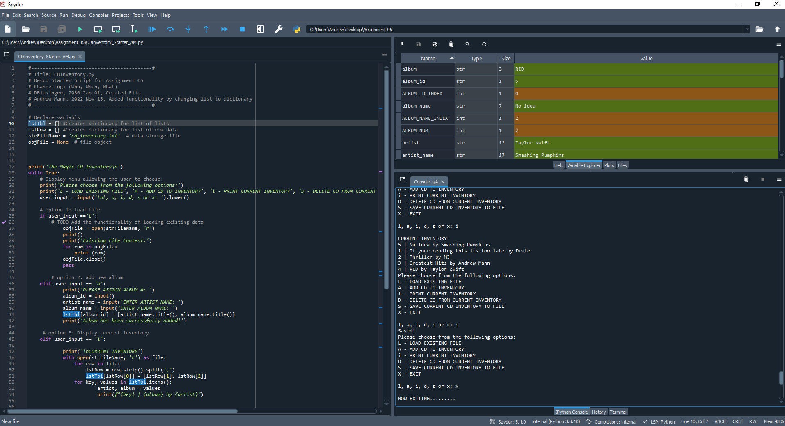

Figure 1: Code working in Spyder

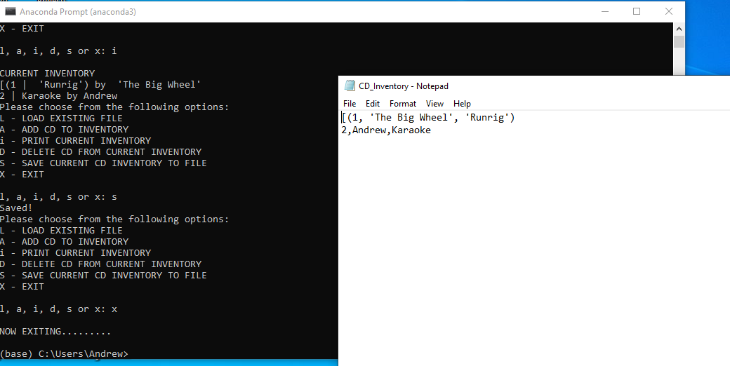

Figure 2: Code working in terminal w/ Saved txt file